|  |
| --- |
| **Consulting** |
| WMS Product Scope |
|  |

 



Content

Introduction 4

1.1 WMS Infrastructure 5

Product Scope 6

1.2 Product search 6

1.3 Bin Management 6

1.4 Multiple UOM 6

1.5 Serial and Batch Managements 6

1.6 Recommendation 6

1.7 Label printing 6

1.8 WMS Manger Portal 6

1.9 Goods Receiving Process 7

1.9.1 Standard Receptions 7

1.9.2 Generic Reception 7

1.9.3 Production Receptions 7

1.9.4 Transfers Receptions (internal shipping) 8

1.9.5 Dynamic Receptions 8

1.9.6 Automatic Batch Creation 8

1.10 Put Away 8

1.10.1 Cross-Docking 8

1.10.2 Refill Process 8

1.10.3 Put Away – Recommendation Rules 8

1.10.4 Pick from Put Away 8

1.11 Picking Process 8

1.11.1 Picking from sales orders 8

1.11.2 Picking from production 9

1.11.3 Picking from inventory transfers 9

1.11.4 Picking from SAP B1 Pick List 9

1.12 Pre-packing 9

1.12.1 Packing 9

1.12.2 Shipping 9

1.12.3 Returns based on RMA 9

1.12.4 Inventory Transfers 9

1.12.5 Inventory Query 9

1.12.6 Add items to bin 9

1.13 Inventory Counting 10

# Introduction

Argentis WMS complements standard SAP Business One logistics and inventory module. The following documents details the product scope and lays the foundation for SAP B1 Partners and end users to evaluate the product functionalities.

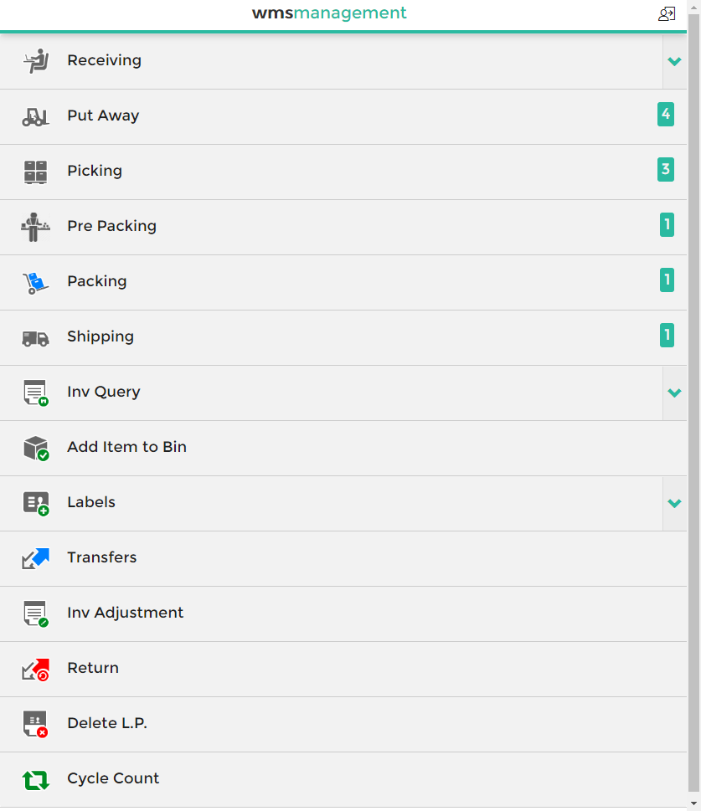

## WMS Infrastructure

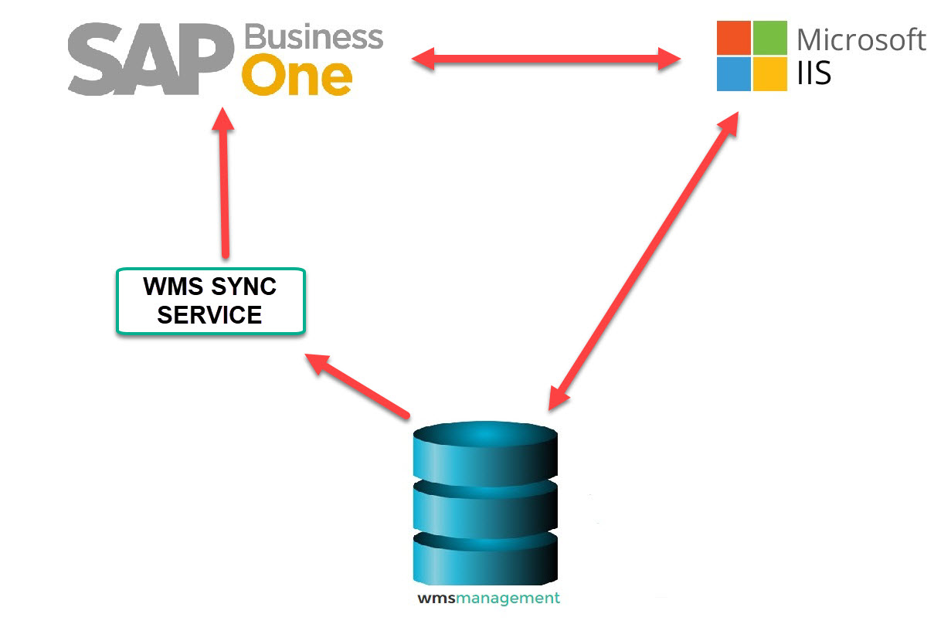

# Product Scope

## Product search

Product search can be carried out from ItemCode, barcode (multiple UOM) EAN 128, EAN13, QR Code

## Bin Management

WMS solution takes standard location, warehouse and bin setups. The user sets up this information in SAP and all the bin location are transferred to the WMS database

## Multiple UOM

Multiple Unit of measure based on SAP Business One item master Settings

## Serial and Batch Managements

WMS solution supports serial and Batch Management for receiving and picking.

Select which number is mandatory (serial or manufacturing number) when receiving or picking items.

On receiving process the batch or serial numbers are created automatically in SAP by the WMS solution

## Recommendation

The solution recommends based on maximum capacity (products or volume), by customer, by speed & sequence, product rotation, or by specific products in the Put Away and picking process

## Label printing



The solution allows users to print UPC, box content, bin location labels using Bartender Software. Labels are pretty much customizable depending on customer requirements.

## WMS Manger Portal



This portal allows users to execute the following tasks:

* User permission (Modules, Warehouses, Bins, etc).
* Error handling.
* BarCode configuration.
* Generic Receptions.
* POI configuration.
* Stock adjustment.
* Printer configuration.
* Reports.

## Goods Receiving Process

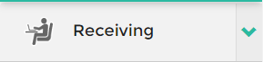

The receiving module can be used to receive goods from purchase orders or reserved invoices created in SAP. Purchase orders can contain items that have to be received in different warehouses and units of measure.

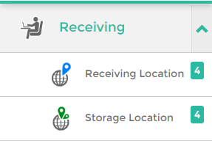

### Standard Receptions

This process starts when the user receives the goods based on an existing Purchase Order. Quantities are stored only in receiving location or in pallets ready to be put away.

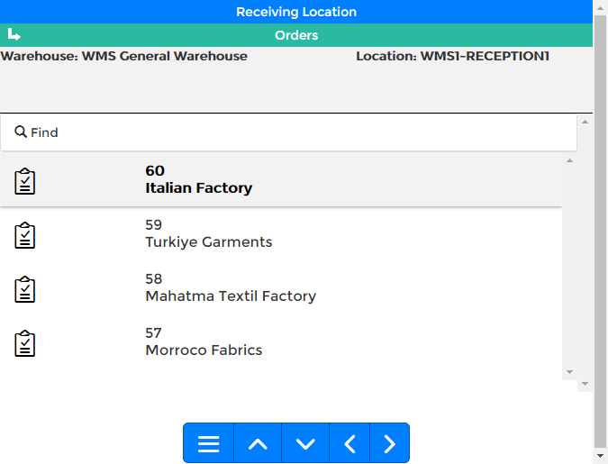

### Generic Reception

This process starts when the user receives the goods not based on an existing Purchase Order. This is the case where there are several POs in a container. Then the product are assigned to a PO manually using WMS manager

### Production Receptions

This is the case where the production department receives the finished product from an internal production order in SAP Business One.

### Transfers Receptions (internal shipping)

This is the process where the user receives goods from an internal inventory transfer request.

### Dynamic Receptions

Quick receipts based on PO but the user can go straight to pallet, receiving location or final stock location. This process is intended to avoid the Put Away process, the stock is recorded directly to a stock location.

### Automatic Batch Creation

The WMS creates batch numbers automatically when receiving the goods. The numbers series are setup in the system (prefix, hour, quantity).

## Put Away



This is the process of moving the items from the receiving bin location to its final location.

### Cross-Docking



The WMS supports the cross-docking process. When receiving the items, the solution match open sales orders and recommends the orders to deliver.

### Refill Process

Define in stock bin locations the minimum and maximus stock. The WMS solution recommends to move items to all bins to fulfill the stock levels.

### Put Away – Recommendation Rules

Define the Put Away rules by volume, batch, customer, location, rotation, capacity, speed and sequence.

### Pick from Put Away

The user can pick items from sales orders during the put away process.

## Picking Process



The picking module in WMS can be used to pick Items from Sales Orders, Reserve Invoices or Pick Lists in SAP.

### Picking from sales orders

The solution allows the users to pick directly from sales orders.

### Picking from production

The solution allows users to pick components from released production orders.

### Picking from inventory transfers

The solution allows users to pick items from inventory transfer request, creating the final transfer in SAP B1.

### Picking from SAP B1 Pick List

Pick items from standard SAP B1 pick list

## Pre-packing



The process is optional, it consist in putting all items for review and move the items to a prepacking section

### Packing



The packing process in WMS generate the packing list in SAP B1 delivery notes. This is an optional process.

### Shipping



Select pick list (orders or pick list) and create delivery notes.

### Returns based on RMA



Select approved RMAs documents and received the goods.

### Inventory Transfers



Move items from one location to another (same or different warehouse).

### Inventory Query



Run inventory queries by products or bin location and Print labels.

### Add items to bin



The purpose of this module is to be able to enter Items that are not in the Warehouse using the WMS. The process is not used to perform an Inventory Transfer. It is used to enter Items into the Warehouse without commercial documents. For example, Items loaned to a provider or concession to a customer.

## Inventory Counting



This module allows use to count items per bin locations, updating inventory levels in SAP when managers agree with the counting.

## 